APPENDIX 2: Kitchen Skills Checklist
Getting Ready
- Reading the recipe carefully
- Checking available ingredients
- Checking available equipment
- Following directions
Clean-Up
- Following food safety guidelines
- Cleaning up
Measuring Basics
- Using kitchen measurements
- Using scales
- Converting amounts
- Using the correct measuring tools
- Measuring dry ingredients
- Measuring liquid ingredients
- Halving/Doubling a recipe
- Understanding of effects of different temperatures
- Other, e.g. ____________________
Food Package Label
- Reading food labels/packaging
- Having an understanding of ingredients, preservatives, food allergies, etc.
- Identifying nutritional content
- Other, e.g. ____________________
Mixing Methods
- Muffin Method
- Biscuit Method
- Cake Method
- Bread Method
- Scone Method
- Other Methods, e.g. ____________________
Techniques
- Shelling an egg
- Separating an egg
- Sifting, blending/whisking
- Creaming
- Cutting-in
- Kneading
- Fermenting, raising, resting, punching
- Folding-in
- Peeling
- Slicing; dicing; grating
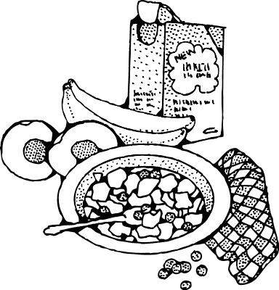
- Rolling out
- Dividing dough
- Making cold cereal
- Making hot cereal
- Making bread/s
- Simmering
- Boiling
- Baking
- Shallow frying
- Grilling
- Poaching
- Seasoning
- Garnishing
- Assisting in preparing and presenting a full Irish cooked breakfast, plated and buffet style
- Assisting in preparing and presenting a continental breakfast, plated and buffet style
- Other, e.g. ____________________
Equipment
- Oven Use
- Microwave Use
- Hand Mixer
- Stand Mixer
- Food Processor
- Bread Machine
- Griddle, skillet, waffle iron
- Other appliances: __________________
Meal Planning
- Menus
- Making lists
- Checking stock
- Costing
- Other, e.g. ____________________
Foods & Nutrition Resources
- Checking nutritional value
- Taking into account dietary requirements
- Other, e.g. ____________________
Safety skills
- Using correct hand-washing techniques
- Following strict protocols in handling, preparing and serving foods
- Cooking at correct temperatures
- Handling and storing food safely
- Using a fire extinguisher correctly
- Keeping kitchen equipment, tools, and practices sanitary
- Understanding of basic principles of food safety and associated legislation
- Compliance with current food safety and hygiene legislation and regulation
- Other, e.g. ____________________
Other kitchen skills
- Using kitchen terminology
- Knife skills-including knife sharpening
- Using proper temperature control when handling all meat, fish, and vegetables
- Selecting and procuring quality ingredients
- Expertise with kitchen tools
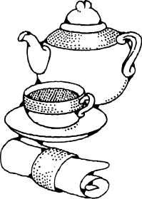
- Being a role model in the kitchen
- Professionalism
- Using imagination and courage to explore
- Using seasoning correctly
- Following a recipe
- Good time management
- A love of cooking
- Focus and attention to detail
- Basic understanding of the food cost and
quality control
- Understanding of a professional kitchen layout
and organisation
- Other, e.g. ____________________
Evaluation skills
- Checking taste
- Checking presentation
- Checking freshness
- Reviewing meal
- Other: ____________

